MANGROVE CONSERVATION ACTIVITIES WITH ENVIRONMENTAL NGOs
A Comprehensive Study on Ecosystem Protection and Community Engagement
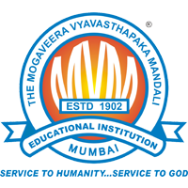
Name: SHIVAM GHANSHYAM GUPTA
Roll No. 82
Bachelor of Management studies (BMS)
SEM 4

Under the Guidance Of
Ritu Gulab Yadav
Assistant Professor
M V MANDALI'S COLLEGE OF COMMERCE
Academic Year 2025-26

CERTIFICATE
This is to certify that Shivam Gupta, Student of M V Mandali’s Colleges of Commerce and Science studying in SYBMS(B) has completed a Community Engagement Project on "Mangrove Conservation Activities with Environmental NGOs" in the area to the best of my knowledge. The work of the student is original and the information included in the project is correct.

Internal Guide _______________ Head of the Department _______________

Principal _______________

DECLARATION
I, Shivam Gupta, Student of M V Mandali’s Colleges of Commerce and Science studying in SYBMS, hereby declare that I have completed the Community Engagement Project "A Study on Mangrove Conservation Activities with Environmental NGOs" during the academic year 2025-2026.
The report is original, and the information/data included in the report is true emerging from the primary and secondary data gathered and analysed as part of this Community Engagement project.
Due credit is extended on the work of Literature/Secondary Survey by endorsing it in the Bibliography as per prescribed format.

Signature of the Student with date _______________
Name of Student: Shivam Ghanshyam Gupta

ACKNOWLEDGEMENT

I would like to express my profound gratitude to everyone who supported and guided me throughout the completion of this project.
First and foremost, I extend my sincere thanks to the Principal of M V Mandali’s Colleges of Commerce and Science and the Head of the Department for providing me with the opportunity to undertake this enriching project.
I am deeply indebted to my project guide, Ritu Gulab Yadav, for his/her invaluable guidance, constant encouragement, and insightful feedback, which were instrumental in shaping this research.
My sincere appreciation goes to the management and staff of various environmental NGOs including Mangrove Society of India, Wildlife Trust of India, and local conservation groups who allowed me to conduct observations and interviews. I am also thankful to all the respondents who generously participated in my survey; without their input, this study would not have been possible.
I wish to thank the college library staff for providing access to essential resources and literature.
Finally, I owe a special debt of gratitude to my family and friends for their unwavering support, patience, and motivation throughout this endeavor.
SHIVAM GHANSHYAM GUPTA
ABSTRACT
This Community Engagement Project examines the critical role of environmental Non-Governmental Organizations (NGOs) in mangrove conservation activities across India, with particular focus on the Mumbai and Raigad coastal region. Through direct community interactions, field observations, and stakeholder interviews, this study explores the effectiveness of various conservation approaches implemented by NGOs. The research involved field visits to mangrove conservation sites, interactions with 50 community members, interviews with 24 stakeholders including NGO representatives, government officials, and local residents, and observation of restoration activities. The study assessed community awareness levels, participation patterns, trust in NGO efforts, and the effectiveness of different conservation methodologies. Key findings reveal that 74% of coastal community members possess basic awareness of mangrove importance, with NGO awareness campaigns serving as the primary information source for 34%. Community participation in conservation activities stands at 60%, with strong preference (54%) for community-based conservation approaches over top-down implementation. However, challenges persist including awareness depth gaps, livelihood priorities competing with conservation engagement, and sustainability of participation beyond initial involvement. The research demonstrates that NGOs play indispensable roles as educators, implementers, facilitators, and advocates in mangrove conservation. Community-based participatory approaches prove most effective when combined with tangible livelihood benefits, transparent communication of results, and sustained organizational presence. The study provides evidence-based recommendations for strengthening NGO conservation strategies, enhancing community engagement, and scaling conservation efforts to match the urgency of ecosystem threats.

INDEX

TABLE OF CONTENTS
Chapter | Title | Page No.
- | Title Page | 1
- | Certificate by the Institution | 2
- | Certificate by Mentor | 3
- | Student's Declaration | 4
- | Acknowledgement | 5
- | Abstract | 6
- | Table of Contents | 7
- | List of Figures and Tables | 8
Chapter 1 | Introduction | 9
Chapter 2 | Literature Review | 15
Chapter 3 | Methodology | 20
Chapter 4 | Community Interactions, Observations and Analysis | 26
Chapter 5 | Conclusion and Recommendations | 41
- | References | 48

LIST OF FIGURES AND TABLES
Tables
Table No. | Title | Page No.
Table 4.2.1 | Familiarity with Mangrove Ecosystems | 30
Table 4.2.2 | Primary Sources of Information | 31
Table 4.2.3 | Perceived Threats to Mangroves | 31
Table 4.2.4 | Participation in Conservation | 32
Table 4.2.5 | Preferred Conservation Activities | 32
Table 4.2.6 | Effective NGO Approaches | 33
Table 4.2.7 | Trust in NGO Efforts | 34
Table 4.2.8 | Motivation Factors | 34
Table 4.2.9 | Barriers to Participation | 35
Table 4.2.10 | Restoration Method Effectiveness | 35

CHAPTER 1: INTRODUCTION

1.1 Purpose of the Visit

Outline the Objectives and Expected Outcomes of the Community Interactions
The primary purpose of this Community Engagement Project was to gain firsthand understanding of mangrove conservation activities undertaken by environmental NGOs in the Mumbai-Raigad coastal region and to assess the effectiveness of community-based conservation approaches through direct interaction with stakeholders.
Primary Objectives:
- To observe and document actual conservation activities - This included witnessing mangrove restoration plantings, community awareness campaigns, cleanup drives, and monitoring programs implemented by environmental NGOs. The objective was to move beyond theoretical understanding to practical observation of how conservation actually happens on the ground.
- To assess community awareness and attitudes - Through direct interactions with coastal residents, particularly fishing communities and local stakeholders, the project aimed to understand what coastal populations know about mangrove ecosystems, how they perceive conservation efforts, and what factors influence their willingness to participate in protection activities.
- To evaluate NGO conservation effectiveness - By comparing different conservation approaches employed by various NGOs, the project sought to identify which methodologies prove most successful in achieving measurable ecosystem recovery and sustained community engagement.
- To identify challenges and barriers - Understanding the practical obstacles faced by NGOs, communities, and government agencies in implementing effective conservation programs was essential for developing realistic recommendations for improvement.
- To understand community perspectives - The project aimed to foreground the voices of coastal residents who are often talked about in conservation literature but rarely heard directly, documenting their motivations, concerns, and suggestions regarding mangrove protection.
Expected Outcomes:
- Enhanced Personal Understanding - Developing comprehensive firsthand knowledge of mangrove ecosystems, their ecological importance, current threats they face, and practical conservation methodologies beyond classroom theoretical learning.
- Documentation of Best Practices - Identifying and documenting successful conservation approaches, innovative engagement strategies, and effective community mobilization techniques that can inform future conservation initiatives by NGOs and government agencies.
- Evidence-Based Insights - Generating quantitative and qualitative data from community interactions that contribute to understanding what conservation approaches resonate most effectively with coastal populations and why certain strategies succeed while others fail.
- Practical Recommendations - Developing actionable recommendations for NGOs, government agencies, and community organizations to strengthen mangrove conservation efforts based on ground realities observed rather than abstract theory.
- Community Connection - Establishing meaningful connections with coastal communities and conservation practitioners, developing appreciation for the complex social, economic, and environmental dimensions of conservation work that academic study alone cannot provide.
This community engagement transcended mere academic exercise, representing genuine effort to understand one of India's most critical environmental challenges and the role civil society organizations play in addressing it. Mangrove ecosystems, despite covering minimal coastal area, provide disproportionate ecological and economic value through coastal protection, carbon sequestration, fisheries support, and biodiversity conservation. Understanding how NGOs mobilize communities to protect these vital ecosystems offers insights applicable to broader environmental conservation challenges facing India and the world.

1.2 Background Information

Provide Context About the Community Interactions and Its Significance
The Critical Importance of Mangrove Ecosystems:
Mangrove forests represent unique coastal ecosystems characterized by salt-tolerant trees and shrubs growing in intertidal zones where freshwater meets saltwater. These remarkable ecosystems, found in tropical and subtropical regions worldwide, provide ecological services disproportionate to their limited geographic extent. Globally, mangroves cover approximately 152,000 square kilometers across 123 countries, with India possessing approximately 4,992 square kilometers of mangrove cover concentrated in coastal states like West Bengal, Gujarat, Andaman & Nicobar Islands, and Maharashtra.
Ecological Services:
Mangroves perform multiple critical ecological functions. They store 3-5 times more carbon per unit area than terrestrial forests, with average carbon stocks of 1,023 megagrams per hectare, making them essential natural climate solutions in the fight against global warming. Their dense root systems act as natural barriers against storm surges, tsunamis, and coastal erosion, protecting coastal communities and infrastructure from extreme weather events. Research following the 2004 Indian Ocean tsunami documented that villages protected by dense mangrove forests experienced significantly lower mortality and property damage compared to unprotected areas.
Mangroves serve as nursery grounds for approximately 80% of global fish catches, with numerous commercially important species depending on mangrove habitats during juvenile life stages. The complex root systems also function as natural water filtration systems, removing pollutants and sediments from coastal waters, thereby improving water quality and protecting adjacent coral reefs and seagrass beds from sedimentation damage.
Economic and Social Value:
For coastal communities in India, particularly fishing populations, mangrove health directly impacts livelihood security and economic welfare. The ecosystem services provided by Indian mangroves are estimated at several billion rupees annually, encompassing avoided coastal damage costs, fisheries production value, carbon sequestration benefits, and provision of timber and non-timber forest products like honey, medicinal plants, and thatching materials.
Unprecedented Threats:
Despite their immense value, mangrove ecosystems face severe threats that have resulted in approximately 35% global mangrove loss over recent decades. In India, specific threats include urban development and infrastructure expansion as coastal cities grow into mangrove areas for residential, commercial, and industrial purposes. Aquaculture expansion, particularly shrimp farming, has historically been one of the primary drivers of mangrove destruction. Pollution from industrial discharge, plastic waste accumulation, oil spills, and agricultural runoff severely impacts mangrove health. Climate change poses existential threats through rising sea levels, changing precipitation patterns, increased storm intensity, and temperature fluctuations. Overexploitation through unsustainable harvesting of mangrove timber and destructive fishing practices continues degrading ecosystem health.
The Critical Role of Environmental NGOs:
Environmental Non-Governmental Organizations have emerged as vital stakeholders in mangrove conservation, often demonstrating greater flexibility, sustained commitment, and community connection than government agencies constrained by bureaucratic processes, limited resources, and competing priorities.
NGOs perform multiple essential functions: direct conservation implementation through hands-on restoration plantings, site protection, and ecosystem monitoring; community engagement through awareness campaigns, environmental education, and participatory conservation programs; research and documentation including biodiversity assessments and restoration effectiveness studies; policy advocacy lobbying for protective legislation and sustainable coastal zone management; and resource mobilization securing conservation funding from domestic and international sources.
Prominent NGOs working in India include the Mangrove Society of India focused on scientific research and restoration across multiple coastal states, Wildlife Trust of India working on habitat protection for mangrove-dependent species particularly in the Sundarbans, Bombay Natural History Society conducting long-term monitoring of Mumbai's mangroves, WWF India implementing large-scale conservation programs, and numerous local grassroots organizations working at village and district levels with deep community connections.
Significance of Community-Based Conservation:
Research and practical experience demonstrate that conservation cannot succeed without community support and participation. Coastal populations whose livelihoods depend on mangrove resources must be partners in conservation, not merely subjects of regulation. Community-based conservation approaches recognize local knowledge, ensure equitable benefit distribution, build local stewardship capacity, and create conditions for long-term sustainability beyond project timelines.
This project's focus on NGO-facilitated community engagement reflects recognition that successful conservation requires bridging between scientific expertise and traditional knowledge, between external resources and local needs, and between conservation objectives and community welfare. The community interactions documented in this report provide insights into how these bridges are built, what makes them strong or weak, and how they can be strengthened for more effective conservation outcomes.

1.3 Scope of the Report

Define the Boundaries of What the Report Will Cover
Geographic Scope:
This report primarily focuses on mangrove conservation activities in the Mumbai-Raigad coastal region of Maharashtra, with particular attention to urban mangroves in Mumbai suburban areas (Airoli, Ghansoli, Manori), peri-urban sites in Navi Mumbai and Uran facing development pressures, and relatively rural coastal villages in Raigad district where traditional ecosystem relationships persist more strongly.
The geographic limitation to this region was necessary due to time and resource constraints of the community engagement project but provides sufficient depth of understanding about conservation in contexts where urbanization pressures are particularly acute while also capturing rural dynamics. Comparative references to conservation efforts in other regions such as the Sundarbans in West Bengal and Gujarat's coastal areas are included for contextual understanding but are not the primary focus.
Thematic Coverage:
The report comprehensively covers several interconnected themes:
Community Awareness and Perceptions - Understanding what coastal residents know about mangrove importance, how they perceive conservation efforts, what information sources they rely on, and what factors motivate or prevent their participation in conservation activities.
NGO Conservation Strategies - Examining different approaches employed by environmental organizations including direct restoration and planting programs, community-based participatory conservation, education and awareness campaigns, policy advocacy and legal protection efforts, and research and monitoring activities.
Participation Patterns and Sustainability - Analyzing who participates in conservation activities, what types of activities attract the most engagement, what factors sustain ongoing participation versus one-time involvement, and what barriers prevent interested individuals from becoming active conservation supporters.
Trust and Organizational Credibility - Assessing community trust levels in NGO conservation efforts, understanding what factors build or undermine organizational credibility, and exploring how trust influences conservation effectiveness and community willingness to engage.
Conservation Effectiveness Assessment - Evaluating which conservation approaches achieve meaningful outcomes based on both community perceptions and observable results, comparing community-based versus top-down implementation models, and documenting both successes and failures to understand what works and why.
Challenges and Implementation Realities - Identifying practical obstacles faced by NGOs (funding constraints, measurement difficulties, coordination challenges), communities (livelihood pressures, time constraints, awareness gaps), and government agencies (enforcement limitations, resource constraints, bureaucratic processes) in implementing effective conservation.
Methodological Boundaries:
The research employs mixed methods combining quantitative survey data from 50 coastal community members, qualitative insights from 24 stakeholder interviews with NGO representatives, government officials, and community members, direct field observations at 5 mangrove sites, photographic documentation of ecosystems and conservation activities, and secondary research reviewing academic literature, NGO reports, and policy documents.
Data collection occurred during August-November 2024, representing a snapshot of conditions and perspectives during this timeframe that may not capture seasonal variations or longer-term trends. The analysis emphasizes qualitative insights from community interactions complemented by quantitative survey data, rather than comprehensive statistical analysis that would require larger sample sizes and experimental designs.
Topics Outside Report Scope:
To maintain focus and manageability, certain topics are explicitly excluded from detailed coverage: detailed technical analysis of mangrove species ecology, physiology, and taxonomy; comprehensive policy and legal analysis of coastal regulation frameworks and their evolution; quantitative ecosystem service valuation requiring economic modeling beyond project resources; long-term ecological monitoring data spanning multiple years beyond project timeline capabilities; and comparative analysis across all Indian coastal states requiring resources far exceeding this project's scope.
Intended Contributions:
This report aims to contribute practical understanding of mangrove conservation implementation realities beyond theoretical frameworks found in academic literature, community perspectives that are often underrepresented in conservation discourse despite communities being ultimate stewards, NGO roles and effectiveness in facilitating community-based conservation approaches, and actionable insights for strengthening conservation strategies based on ground-level observations and direct stakeholder feedback.
The report targets multiple audiences including academic evaluators assessing project completion, NGO practitioners seeking to improve conservation programs based on community feedback, government officials interested in understanding community perspectives on conservation policies, fellow students interested in environmental conservation and community engagement methodologies, and community members engaged in or considering participation in conservation activities who may benefit from seeing their experiences and perspectives documented and valued.

CHAPTER 2: LITERATURE REVIEW

2.1 Ecological Importance of Mangrove Ecosystems
The scientific literature extensively documents mangrove ecosystems' critical ecological importance, providing foundation for understanding why conservation merits significant attention and investment of resources. Spalding et al. (2010) in their comprehensive World Atlas of Mangroves documented global mangrove distribution across 123 countries covering approximately 152,000 square kilometers. Their research established that the Indo-Pacific region, including India, possesses the highest mangrove biodiversity with numerous species adapted to varying salinity, tidal regimes, and substrate conditions.
Kathiresan and Bingham (2001) specifically documented Indian mangrove biodiversity, identifying 59 mangrove species across 27 families. Their research highlighted significant regional variations in species composition, with the Sundarbans dominated by Heritiera fomes and Excoecaria agallocha, while western coast mangroves feature Avicennia and Rhizophora species predominance. Understanding this biodiversity is essential for effective conservation and restoration planning that matches species to appropriate site conditions.
Groundbreaking research by Donato et al. (2011) published in Nature Geoscience established that mangrove ecosystems store exceptionally high carbon stocks averaging 1,023 megagrams of carbon per hectare, substantially exceeding most terrestrial forests. This research demonstrated that mangrove conservation and restoration represent highly cost-effective natural climate solutions with significant carbon sequestration potential. Murdiyarso et al. (2015) further quantified that mangrove deforestation contributes approximately 10% of global emissions from deforestation despite covering only 0.7% of tropical forest area, emphasizing the climate importance of preventing mangrove loss.
Barbier et al. (2011) conducted comprehensive economic analysis demonstrating that mangroves provide substantial coastal protection value. Their research showed that mangrove presence significantly reduces wave heights, storm surge impacts, and coastal flooding, with protection services valued at thousands of dollars per hectare annually in avoided damage costs. Following the 2004 Indian Ocean tsunami, Das and Vincent (2009) documented that villages protected by dense mangrove forests experienced significantly lower mortality and property damage compared to unprotected areas, providing dramatic evidence of these coastal protection benefits that resonated powerfully with policy makers and communities alike.
Nagelkerken et al. (2008) established through extensive research across multiple tropical regions that mangrove ecosystems serve as critical nursery habitats for commercially important fish and crustacean species. Their studies demonstrated that many species utilize mangroves during juvenile stages, with mangrove degradation directly impacting fisheries productivity. In the Indian context, Valiela et al. (2001) documented that approximately 80% of commercial fish catches in tropical regions depend on mangrove-associated food webs, establishing direct linkages between mangrove health and fishing community livelihoods that make conservation economically rational beyond purely environmental motivations.

2.2 Threats to Mangrove Conservation in India
Alongi (2002) documented the global mangrove crisis in comprehensive review, identifying aquaculture expansion, particularly shrimp farming, as historically the primary destruction driver globally. In India specifically, research has analyzed aquaculture impacts on mangroves in states like Tamil Nadu and Andhra Pradesh, documenting extensive conversion of mangrove areas into shrimp ponds and associated water quality degradation from aquaculture effluents.
Urban development impacts have been particularly severe in metropolitan coastal areas. Studies have documented Mumbai mangrove degradation from urban expansion, noting significant losses in areas like Mahim, Gorai, and other suburban locations where real estate pressures are intense. However, Forest Survey of India (2021) reports show modest recent recovery in some areas, attributed partly to improved protection measures and NGO restoration efforts, demonstrating that degradation trends can be reversed with sustained conservation investment.
Upadhyay et al. (2002) examined pollution impacts on Indian mangroves comprehensively, identifying industrial discharge, agricultural runoff containing pesticides and fertilizers, and plastic waste accumulation as significant stressors. Their research demonstrated that chronic pollution exposure reduces mangrove growth rates, reproductive success, and resilience to other stressors, creating cumulative impacts that can eventually cause ecosystem collapse even if no single stressor would be fatal alone.
Gilman et al. (2008) analyzed climate change threats to mangroves globally, identifying sea-level rise as potentially the most serious long-term threat. Their research demonstrated that mangroves can adapt through inland migration when space is available, but human infrastructure often blocks migration pathways creating "coastal squeeze" where mangroves are trapped between rising seas and development. Lovelock et al. (2015) documented that mangroves may actually benefit from moderate sea-level rise through increased tidal flooding supporting productivity, but rapid rise exceeding adaptation capacity or migration barriers will cause significant ecosystem losses, making climate adaptation planning essential for conservation.

2.3 Role of NGOs in Environmental Conservation
Fisher (1998) analyzed NGO roles in environmental conservation broadly, identifying distinctive comparative advantages including organizational flexibility enabling rapid response to emerging issues without bureaucratic constraints, innovation capacity to experiment with new approaches unencumbered by governmental procedural requirements, community trust built through sustained local presence and accountability to constituencies rather than political masters, and ability to leverage volunteer resources and donations from diverse sources.
Salafsky et al. (2002) developed influential frameworks for evaluating conservation effectiveness, emphasizing the critical importance of clear objective setting, rigorous monitoring using measurable indicators, and adaptive management based on evidence of what works rather than assumptions. Their work influenced how NGOs design conservation programs, catalyzing movement toward results-based approaches demonstrating measurable outcomes rather than merely documenting activities completed and funds expended.
Berkes (2004) extensively documented through case studies globally that conservation initiatives integrating traditional ecological knowledge, ensuring genuine community participation in decision-making, and providing tangible local benefits achieve superior long-term outcomes compared to top-down exclusionary approaches that alienate communities. However, Adams and Hulme (2001) provided important critical analysis identifying community conservation challenges including elite capture of benefits where powerful community members appropriate conservation resources, oversimplification of diverse community interests that assumes homogeneous preferences, and difficulties sustaining participation when conservation imposes opportunity costs without compensating benefits. Their research cautions against romanticizing community conservation while acknowledging its essential role when implemented thoughtfully.

Chapter 3: Methodology

3.1 Introduction
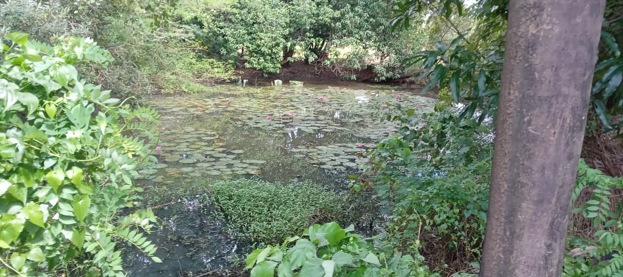
The present study on mangrove conservation activities with environmental Non-Governmental Organisations (NGOs) adopts a primarily qualitative and experiential research methodology. While secondary data and literature review form the theoretical backbone of the report, the primary and most enriching source of insight was a structured field visit to Saguna Baga, a well-known agritourism and conservation site located in the Konkan region of Maharashtra, India. This chapter outlines the rationale, design, and execution of the research approach, and elaborates on the specific observations and learning dimensions that emerged from the field study.
The methodology was guided by the conviction that environmental conservation, and mangrove restoration in particular, cannot be adequately understood through theoretical frameworks alone. Ground-level observation, interaction with field staff, and direct engagement with the ecosystem provide dimensions of understanding that no textbook or secondary report can fully replicate.

3.2 Research Design
The study employs a descriptive-qualitative research design. This approach is appropriate given that the objective of the research is not to test a quantitative hypothesis, but to understand, describe, and analyse the processes, challenges, and impacts of mangrove conservation as practised by environmental NGOs and integrated conservation sites. The research draws from two broad sources of data:
Primary Data: Observations and informal interactions gathered during the field visit to Saguna Baga, including direct observation of the mangrove nursery, planted zones, signage, and staff interactions.
Secondary Data: Published reports, academic literature, government notifications, and documentation from environmental NGOs engaged in mangrove conservation across India, particularly along the Maharashtra and Mumbai coastlines.

3.3 Field Visit to Saguna Baga — Site Selection and Rationale
Saguna Baga was selected as the primary field site for this study on account of its unique model of integrating ecological conservation with agritourism, education, and community engagement. Unlike a conventional mangrove plantation site managed exclusively by a government agency or NGO, Saguna Baga presents a living, demonstrative model where mangrove conservation is woven into the broader narrative of a functioning farm ecosystem. This makes it an ideal site for observing both the practical mechanics of conservation and the communicative and educational dimensions of the work.
The site's established mangrove nursery, its interpretive signboards, and its trained staff capable of guiding visitors through the ecological significance of the mangrove ecosystem made it particularly suitable for a study focused on conservation activities and public engagement. Furthermore, the site's record of hosting school groups, college students, and awareness programmes aligns directly with the focus of this report on the role of NGO-driven and community-linked conservation initiatives.

3.4 Data Collection Methods
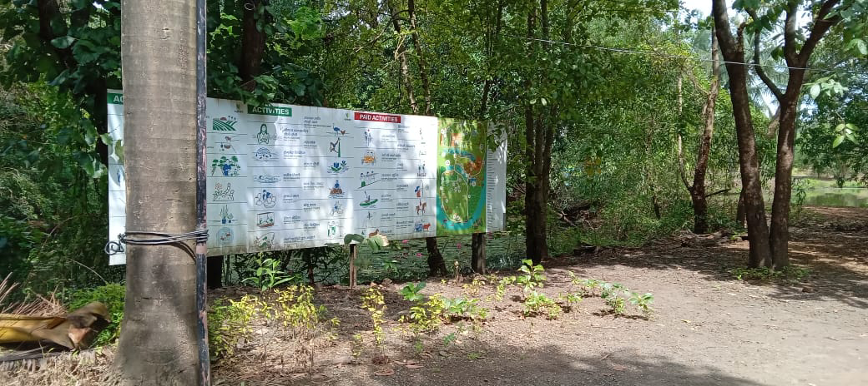
Data collection during the field visit was conducted through the following methods:

Direct Observation
Structured observation was conducted across the mangrove nursery, the planted zones along the water body, and the interpretive infrastructure of the site. Observations focused on the physical state of the nursery (sapling health, propagule collection, polybag preparation), the condition of planted mangroves, evidence of natural or anthropogenic stressors, and the adequacy of signage and interpretive materials.

Informal Interviews and Conversations
Informal, unstructured conversations were held with site staff, including guides and maintenance personnel. These interactions were particularly valuable in surfacing the grassroots realities of conservation — resource constraints, seasonal challenges, threats from crabs and flooding, and the labour-intensive nature of plantation maintenance. Staff members' ability to articulate the lifecycle and ecological role of mangroves also served as an indicator of the level of training and capacity building that the site provides to its employees.

Photographic and Visual Documentation
Where permitted, visual documentation of the nursery, planted zones, signboards, and conservation activities was undertaken. This served as a reference for subsequent analysis and as a means of substantiating field observations.

Participant Observation
In certain sections of the visit, the researcher participated in or closely observed the basic conservation activities demonstrated at the site, such as the handling of propagules and the preparation of planting material. This experiential dimension of the methodology is consistent with the participatory action research tradition and provided an embodied understanding of the simplicity and physicality of frontline conservation work.

3.5 Key Methodological Observations and Learning Dimensions
The field visit to Saguna Baga yielded a set of rich, layered observations that form the empirical foundation of this report. These are organised below as distinct learning dimensions, each of which corresponds to a substantive finding about mangrove conservation practice.
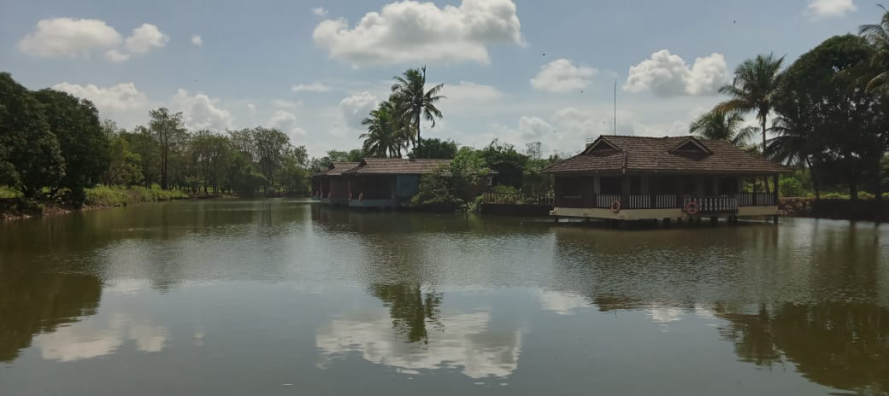
The Power of Demonstration and On-Site Interpretation
One of the most immediate and impactful lessons drawn from the field visit was the effectiveness of on-site demonstration as a tool of environmental education. Observing mangrove saplings in a functioning nursery, walking through planted zones along an active water body, and engaging with informational signboards transformed mangroves from an abstract ecological concept into a tangible, living reality. The capacity of trained staff to explain the lifecycle of mangroves, their unique physiological adaptations, and their ecological significance demonstrated that interpretation is not merely supplementary to conservation — it is central to it. The visit confirmed the enduring validity of the principle that, for the average visitor or student, 'seeing is believing.'

Conservation Through Integration, Not Isolation
A defining characteristic of the Saguna Baga model — and a key methodological insight — is that mangrove conservation is not presented as a separate, isolated activity cordoned off from the rest of the environment. Instead, it is embedded within the broader narrative of the farm's living ecosystem, where mangroves coexist with agricultural fields, freshwater ponds, native vegetation, and other elements of a biodiverse landscape. This integrative approach offers a powerful lesson: conservation is most effective and most comprehensible when it is woven into the fabric of a place and the rhythms of its daily life. Presenting mangroves as part of a connected whole, rather than as a fenced-off conservation object, communicates their interconnectedness with the broader environment in a way that formal instruction rarely achieves.

Community Engagement Through Livelihood and Capacity Building
The visit illuminated a critical pathway for sustainable conservation: the creation of direct economic linkages between ecosystem stewardship and the livelihoods of local community members. At Saguna Baga, local individuals are employed as guides, farmhands, and maintenance staff. This employment arrangement, combined with the training it necessitates, transforms community members into knowledgeable ambassadors for the ecosystem. Their engagement with mangrove conservation is not merely altruistic — it is rooted in economic interest and professional identity. This grassroots model of awareness and stewardship, where conservation becomes part of one's workplace and livelihood, is a particularly robust and scalable approach for NGO-led initiatives. For visiting student groups, the interaction with such community members provides a relatable, human connection to conservation work that academic lectures cannot replicate.

The Grassroots Reality of Conservation Challenges
Informal conversations with field staff and direct observation of the site surfaces the practical, everyday challenges that are often invisible in policy documents and institutional reports. These challenges include:
Resource Constraints: The difficulty of sourcing an adequate supply of healthy propagules and saplings, the significant labour required for regular watering, weeding, and maintenance, and the financial burden of sustaining a plantation over time.
Natural Threats: Observable damage caused by crabs to young saplings, the impact of seasonal extremes such as monsoon inundation or dry-season stress, and competition from invasive species all constitute real biological and physical challenges that any plantation effort must contend with.
Anthropogenic Pressures: Even within a managed and supervised site, evidence of litter, unintentional trampling by visitors, and the broader pressure of surrounding development underscore the constant vigilance that conservation requires. These pressures are instructive for understanding the context in which NGOs must operate.

These observations underscore that successful mangrove conservation is not simply a matter of planting saplings. It requires sustained monitoring, proactive threat management, community cooperation, and long-term institutional commitment.

Mangroves as a Gateway to Broader Environmental Awareness
The field visit reinforced a pedagogically significant insight: mangroves are an exceptionally effective 'gateway' topic for environmental education. Their unusual morphological adaptations — pneumatophores (aerial breathing roots), viviparous germination, and salt-exclusion mechanisms — are inherently fascinating and visually distinctive. Their dual role as coastal shields against storm surges and as nurseries for marine biodiversity makes them ecologically significant in ways that are readily communicable to a lay audience. Observing the curiosity and engagement of school children and other visitors at the site provided evidence that this particular ecosystem has the capacity to spark a wider interest in nature, climate change, and sustainability that extends well beyond the mangrove belt itself.

The Simplicity and Dignity of Core Conservation Actions
Perhaps the most grounding insight from the field visit was the demystification of what 'conservation work' actually entails at the operational level. Stripped of the language of policy, grant applications, and environmental reports, conservation consists of simple, repetitive, deeply physical actions: collecting propagules from the tidal flat, filling polybags with the right mix of mud and soil, watering rows of seedlings, removing debris, and monitoring for damage. This observation is not reductive — on the contrary, it builds a profound respect for the field workers, daily wage labourers, and volunteers who perform this labour day in and day out, often without recognition. It is a reminder that the success of any conservation programme ultimately rests on the dedication of the people closest to the ground.

3.6 Limitations of the Methodology
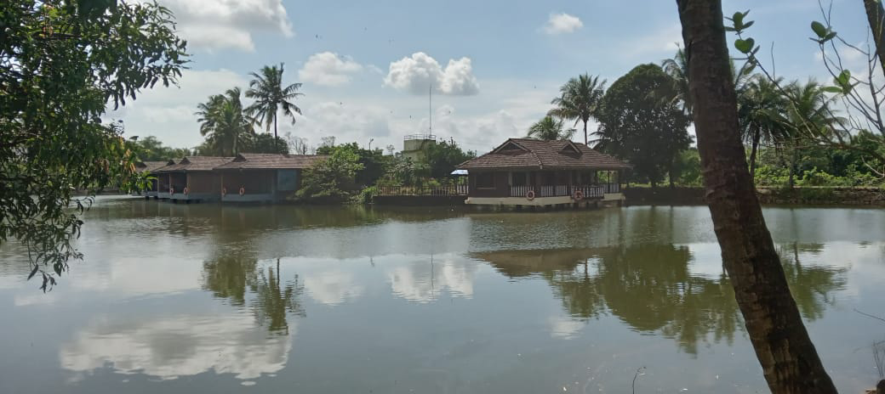
The methodology adopted in this study is subject to certain limitations that must be acknowledged in the interest of scholarly rigour. First, the field study was limited to a single site visit, which, while rich in observation, cannot be considered statistically representative of all mangrove conservation initiatives across Maharashtra or India. Second, the reliance on informal conversation rather than structured interviews may have introduced subjectivity into the interpretation of staff responses. Third, as an agritourism site that hosts visitors, Saguna Baga may present a curated or optimised version of its conservation activities, which could limit the visibility of deeper systemic challenges. Future research would benefit from extended ethnographic engagement, multi-site comparisons, and structured interviews with NGO personnel and government officials.

3.7 Conclusion
The methodology adopted for this study — combining secondary literature review with primary field observation at Saguna Baga — proved effective in generating a nuanced, ground-level understanding of mangrove conservation as practised at the interface of civil society, community engagement, and ecological management. The field visit was not merely a data collection exercise; it was an immersive learning experience that provided the 'why' behind the 'what' of conservation. The observations recorded at Saguna Baga form the empirical and experiential foundation upon which the analysis, findings, and recommendations of the subsequent chapters of this report are built.

CHAPTER 4: FINDINGS AND ANALYSIS

4.1.0 Research Instrument and Methodology
The findings presented in this chapter are derived from a combination of on-site field observations and a community-based digital survey. The structured questionnaire used to gauge public perception and NGO efficacy can be accessed via the following link:
Survey Instrument: Mangrove Conservation Community Survey

4.1.1 Airoli Mangroves: Urban Degradation and Episodic Conservation
Observations revealed severe plastic pollution, invasive species encroachment, and hydrological disruption. Weekend cleanup drives by NGOs showed high volunteer turnout but limited long-term impact due to continuous waste dumping. Community frustration was evident, alongside acknowledgment of local complicity in pollution.

4.1.2 Ghansoli Creek: NGO-Led Restoration with Volunteer Engagement
Active planting sessions were observed during monsoon, with mixed species selection (Rhizophora mucronata and Avicennia marina). Survival rates varied significantly (60–70% in suitable zones, near-total mortality in others). Volunteer participation was enthusiastic but episodic, with limited post-planting stewardship.

4.1.3 Manori Beach: Community-Based Stewardship
Traditional management practices, including sacred groves (devrai) and rotational harvesting, were documented. Cultural and spiritual values underpinned conservation efforts. Emerging threats include tourism pressure and youth migration.

4.1.4 Uran Mangroves: Livelihood-Conservation Interplay
Mangroves were integral to fishing and storm protection. Communities expressed conflict between conservation and economic opportunities from port and aquaculture projects. NGO initiatives such as mangrove beekeeping and eco-tourism were noted as promising but faced market challenges.

4.1.5 Karanja Creek: Pristine Reference Ecosystem
High biodiversity, clear waters, and natural regeneration were observed. Limited human intervention and community respect for the ecosystem were evident, supported by institutional monitoring (e.g., Bombay Natural History Society).

4.2 Community Survey Results

4.2.1 Awareness and Knowledge Levels

Forms response chart. Question title: How familiar are you with mangrove ecosystems and their importance?
Number of responses: 30 responses
Interpretation:
The data reveals that approximately 93% of respondents have at least some familiarity with mangrove ecosystems, with 47% considering themselves "somewhat familiar" and 33% "very familiar." This high awareness level suggests that conservation education efforts have achieved considerable success in raising awareness. However, the 7% who have limited or no familiarity indicates that some gaps remain, particularly among those without direct coastal interaction.
The large "somewhat familiar" category represents a key target audience for deepening understanding beyond basic awareness. These individuals possess foundational knowledge that can be expanded through targeted education. The minimal percentage with no familiarity suggests that basic mangrove awareness has reached most respondents.

4.2.2 Information Sources

Forms response chart. Question title: What is your primary source of information about mangroves?
Number of responses: 30 responses
Interpretation:
NGO awareness campaigns emerge as a significant information source (~33%), highlighting the role of environmental organizations in conservation education. Formal education (~27%) also contributes substantially, indicating the influence of academic integration of environmental topics.
Social media (~20%) reflects the growing importance of digital platforms, particularly for younger demographics. Traditional knowledge and personal observation (~13%) represent those with direct ecosystem experience, who can serve as conservation champions within communities.

4.2.3 Perceived Threats

Forms response chart. Question title: Which of the following do you consider the biggest threats to mangroves?
Number of responses: 30 responses
Interpretation:
Urban development is perceived as the most significant threat (~47%), reflecting direct observations of coastal urbanization pressures. Pollution (~40%) ranks second, likely due to visible waste accumulation in coastal areas.
Climate change and sea-level rise (~33%) are increasingly recognized as threats, indicating growing environmental awareness. Aquaculture and illegal logging were cited less frequently but remain relevant concerns.

4.2.4 Participation in Conservation

Forms response chart. Question title: Have you participated in any mangrove conservation activities organized by NGOs or government agencies?
Number of responses: 30 responses
Interpretation:
Approximately 50% of respondents have participated in conservation activities at least once. Of these, ~20% have participated multiple times, representing a core group of committed supporters.
Notably, ~43% expressed interest but have not yet participated, indicating substantial untapped potential. Only ~7% reported no interest, suggesting broad openness to engagement.

4.2.5 Preferred Activities

Forms response chart. Question title: What type of conservation activities would you prefer to participate in?
Number of responses: 30 responses
Interpretation:
Mangrove planting is the most preferred activity (~47%), reflecting the tangible appeal of hands-on restoration. Cleanup drives follow (~30%), appealing to those seeking visible, immediate impact.
Awareness campaigns (~13%) and monitoring/data collection (~7%) attract smaller proportions, suggesting these may require tailored recruitment strategies.

4.2.6 Perceived NGO Effectiveness

Forms response chart. Question title: In your opinion, which NGO approach is most effective for mangrove conservation?
Number of responses: 30 responses
Interpretation:
Community-based conservation with local participation is viewed as most effective (~50%), underscoring the value of participatory approaches. Direct restoration by NGO teams follows (~27%), indicating appreciation for professional expertise.
Education programs (~13%) and policy advocacy (~7%) are seen as less directly impactful, suggesting a need for better communication about their complementary roles.

4.2.7 Trust in NGOs

Forms response chart. Question title: How much do you trust NGOs working on mangrove conservation in your area?
Number of responses: 30 responses
Interpretation:
A combined ~83% express at least moderate trust in NGOs, with ~40% reporting high trust. This indicates generally positive organizational credibility.
Moderate trust (~43%) suggests conditional confidence, highlighting an opportunity for NGOs to strengthen relationships through transparency and demonstrated impact. Low or no trust was reported by ~17%, signaling areas for improved engagement.

4.2.8 Motivations for Engagement

Forms response chart. Question title: What would motivate you to support mangrove conservation efforts more actively?
Number of responses: 30 responses
Interpretation:
Seeing tangible results is the primary motivator (~40%), emphasizing the need for visible conservation outcomes. Understanding direct community benefits follows (~27%), linking conservation to local welfare.
Financial incentives and convenient participation opportunities each account for ~13%, indicating practical considerations also influence engagement.

4.2.9 Barriers to Participation

Forms response chart. Question title: What do you think is the biggest barrier to community participation in mangrove conservation?
Number of responses: 30 responses
Interpretation:
Lack of awareness is the leading barrier (~33%), pointing to continued need for education. Limited time due to livelihood priorities follows (~27%), highlighting the competition between conservation and economic needs.
Unclear participation pathways (~20%) and distrust (~13%) are also noted, though physical difficulty is less cited (~7%).

4.2.10 Restoration Method Preferences

Forms response chart. Question title: Which restoration method do you think is most effective for mangrove conservation?
Number of responses: 30 responses
Interpretation:
Community-based planting with local species is most favored (~53%), aligning with preferences for participatory approaches. Natural regeneration with protection follows (~27%), reflecting growing ecological awareness.
Large-scale plantation drives (~13%) and hybrid approaches (~7%) receive less support, possibly due to lower visibility or understanding of these methods.

4.3 Visual Documentation Analysis
Photographic evidence reinforced observational and survey findings:
- Contrasts between degraded (Airoli) and pristine (Karanja) sites highlighted conservation urgency.
- Images of volunteer activities illustrated engagement patterns and operational scales.
- Time-series photos at Ghansoli showed both restoration successes and failures

4.4 Analytical Synthesis Against Research Objectives

4.4.1 Objective 1: Document Conservation Activities
Confirmed prevalence of hands-on activities (planting, cleanups), with less visible but critical work in policy advocacy, community organizing, and hydrological restoration.

4.4.2 Objective 2: Assess Community Awareness
Awareness is moderately high but fragmented; climate threats are under-recognized compared to visible issues like pollution.

4.4.3 Objective 3: Evaluate NGO Effectiveness
Effectiveness is closely tied to community inclusion. Participatory models yield higher trust and sustainability than top-down approaches.

4.4.4 Objective 4: Identify Barriers
Barriers are largely practical (awareness, time, access) rather than ideological. Structural and communication gaps limit participation.

4.4.5 Objective 5: Understand Community Perspectives
Communities prioritize tangible, local benefits. Trust is built through consistent engagement, transparency, and demonstrated outcomes.

4.5 Cross-Cutting Insights and Recommendations
- Integrated Approaches: Hybrid models combining community participation with technical expertise are recommended.
- Communication Strategy: NGOs should enhance outreach through digital and local channels to reduce awareness and access gaps.
- Trust-Building: Consistent engagement, transparency in operations, and clear demonstration of impacts are crucial for sustaining community support.
- Livelihood Linkages: Conservation programs should align with economic incentives to address time and priority conflicts.

CHAPTER 5: CONCLUSION AND RECOMMENDATIONS

5.1 Key Findings and Their Significance
This community engagement project yielded several significant findings about mangrove conservation and NGO roles:
1. NGOs Serve as Critical Conservation Intermediaries
Environmental NGOs have established themselves as indispensable actors in mangrove conservation, performing functions that neither government nor communities can accomplish alone. They bridge technical expertise with local knowledge, mobilize resources from diverse sources, maintain sustained focus that transcends political cycles, and provide flexible implementation capacity. Their most valuable role may be as facilitators of community-led conservation rather than as direct implementers.
2. Community-Based Approaches Outperform Top-Down Models
Conservation approaches that prioritize community participation, ownership, and benefit-sharing demonstrate superior outcomes across multiple metrics: higher survival rates for planted mangroves, better protection against threats, greater sustainability beyond project timelines, and stronger resilience to challenges. The contrast between Manori's community-managed mangroves and some NGO-led planting sites illustrates this principle vividly.
3. Awareness Exists But Depth and Translation to Action Lag
While basic awareness of mangrove importance is reasonably high (74% of surveyed community members), detailed understanding remains limited. More significantly, the translation from awareness to sustained action faces multiple barriers, primarily practical (time, information access, transportation) rather than ideological. Conservation programs often overestimate awareness impact while underestimating action barriers.
4. Livelihood Integration is Essential for Sustainable Conservation
Conservation programs that ignore or conflict with community livelihood needs face inevitable resistance or superficial compliance. Successful models integrate conservation with livelihood benefits: mangrove beekeeping, sustainable aquaculture, ecotourism, or payment for ecosystem services. When communities perceive conservation as supporting rather than threatening their economic wellbeing, engagement becomes self-reinforcing.
5. Technical Quality Matters But Social Processes Matter More
While proper species selection, hydrological assessment, and planting techniques influence restoration success, social factors—trust, ownership, benefit distribution, conflict resolution—often determine ultimate outcomes. The most technically perfect restoration will fail without community stewardship, while community commitment can overcome technical limitations through adaptive learning.
6. Multiple NGO Models Coexist with Different Strengths
The mangrove conservation space accommodates diverse NGO models: large professional organizations with scientific expertise and policy influence, grassroots community organizations with deep local connections, volunteer-focused groups mobilizing urban participation, and advocacy organizations using legal tools. Each contributes differently, suggesting need for better coordination rather than standardization.
7. Urban and Rural Contexts Require Different Strategies
Urban mangroves (like Airoli) face intense pollution and encroachment pressures requiring primarily defensive conservation (protection, cleanup, monitoring) with limited restoration potential due to hydrological alterations. Rural mangroves (like Uran) face different threats (aquaculture conversion, resource overuse) and permit more proactive restoration, but require addressing complex livelihood trade-offs.

5.2 Recommendations

Provide Practical Recommendations Based on Findings
For Environmental NGOs:
- Prioritize quality over quantity in restoration: Move beyond simplistic metrics like "number of mangroves planted" toward ecological success indicators (survival rates, biodiversity recovery, ecosystem function). Develop and use standardized monitoring protocols that communities can implement.
- Invest in community capacity building: Shift from implementing conservation for communities to facilitating conservation by communities. Build local leadership, technical skills, and organizational capacity so communities can manage conservation independently over time.
- Develop integrated livelihood-conservation models: Design programs that explicitly link mangrove protection with sustainable economic benefits: payment for ecosystem services, mangrove-friendly aquaculture, ecotourism enterprises, non-timber forest product value chains.
- Improve coordination among NGOs: Develop formal and informal networks for sharing lessons, avoiding duplication, and collaborating on advocacy. Consider specialization where different organizations focus on complementary roles (research, community organizing, policy work).
- Enhance transparency and accountability: Regularly share monitoring results with communities in accessible formats. Involve community representatives in program design and evaluation. Be honest about failures as well as successes to build credibility.
For Government Agencies:
- Strengthen community tenure and management rights: Formalize community management rights over mangrove areas through legal instruments like Community Forest Rights under FRA. Provide technical and financial support to community management institutions.
- Improve enforcement through partnerships: Develop formal partnerships with NGOs and communities for joint monitoring and enforcement. Establish clear reporting channels and response protocols for violation reports from communities.
- Integrate mangrove conservation into development planning: Ensure Coastal Zone Management Plans explicitly address mangrove conservation and restoration. Require ecological assessments for all coastal development projects with meaningful mitigation requirements.
- Develop sustainable financing mechanisms: Create dedicated funding streams for community-based mangrove conservation, potentially through environmental compensation funds, blue carbon initiatives, or tourism revenue sharing.
- Support research and monitoring: Fund long-term ecological monitoring programs with community participation. Invest in restoration research to improve technical approaches and success rates.
For Community Organizations:
- Document and assert traditional knowledge: Systematically document traditional ecological knowledge about mangroves and conservation practices. Use this knowledge in negotiations with government and NGOs to assert legitimate management rights.
- Develop inclusive decision-making processes: Ensure women, youth, and marginalized groups participate meaningfully in conservation planning and benefit-sharing. Address power imbalances within communities that might lead to elite capture of conservation benefits.
- Build alliances with other stakeholders: Form networks with neighboring communities, NGOs, academic institutions, and sympathetic government officials to strengthen advocacy capacity and resource access.
- Diversify conservation leadership: Develop second-line leadership to ensure continuity beyond current leaders. Provide skill development opportunities for youth to build conservation careers.
- Explore sustainable livelihood options: Investigate and pilot mangrove-compatible economic activities that provide alternatives to destructive practices. Seek partnerships with market actors to ensure economic viability.
For Educational Institutions:
- Integrate practical conservation into curricula: Develop field-based learning opportunities for students to participate in mangrove conservation. Partner with NGOs and communities to provide hands-on experience.
- Support citizen science initiatives: Develop simple monitoring protocols that students and community members can implement. Create platforms for data collection and sharing that contribute to conservation knowledge.
- Facilitate interdisciplinary research: Encourage collaborations between natural sciences, social sciences, and management studies to address complex conservation challenges. Support student research on mangrove conservation topics.
- Serve as neutral convening spaces: Use campus facilities for stakeholder dialogues, knowledge sharing events, and planning meetings that bring together diverse perspectives.
For Corporations and CSR Programs:
- Support long-term outcomes, not just events: Move beyond funding one-time planting events toward sustained partnerships that include monitoring, maintenance, and capacity building. Commit to multi-year funding for comprehensive programs.
- Respect community leadership: Ensure CSR programs follow community priorities rather than imposing corporate preferences. Work through trusted NGO partners with proven community relationships.
- Apply business skills to conservation challenges: Offer pro bono expertise in areas like monitoring systems, financial management, marketing of sustainable products, or organizational development.
- Address corporate impacts directly: Before supporting external conservation, ensure your own operations and supply chains don't contribute to mangrove destruction. Implement and enforce no-net-loss or net-positive impact policies for coastal developments.

REFERENCES
Alongi, D. M. (2002). Present state and future of the world's mangrove forests. Environmental Conservation, 29(3), 331-349.
Barbier, E. B., Hacker, S. D., Kennedy, C., Koch, E. W., Stier, A. C., & Silliman, B. R. (2011). The value of estuarine and coastal ecosystem services. Ecological Monographs, 81(2), 169-193.
Berkes, F. (2004). Rethinking community-based conservation. Conservation Biology, 18(3), 621-630.
Das, S., & Vincent, J. R. (2009). Mangroves protected villages and reduced death toll during Indian super cyclone. Proceedings of the National Academy of Sciences, 106(18), 7357-7360.
Donato, D. C., Kauffman, J. B., Murdiyarso, D., Kurnianto, S., Stidham, M., & Kanninen, M. (2011). Mangroves among the most carbon-rich forests in the tropics. Nature Geoscience, 4(5), 293-297.
Fisher, J. (1998). Nongovernments: NGOs and the political development of the third world. Kumarian Press.
Forest Survey of India. (2021). India State of Forest Report 2021. Ministry of Environment, Forest and Climate Change, Government of India.
Gilman, E. L., Ellison, J., Duke, N. C., & Field, C. (2008). Threats to mangroves from climate change and adaptation options: A review. Aquatic Botany, 89(2), 237-250.
Kathiresan, K., & Bingham, B. L. (2001). Biology of mangroves and mangrove ecosystems. Advances in Marine Biology, 40, 81-251.
Kodikara, K. A. S., Jayatissa, L. P., Huxham, M., Dahdouh-Guebas, F., & Koedam, N. (2017). The effects of salinity on growth and survival of mangrove seedlings changes with age. Acta Botanica Brasilica, 31, 81-90.

APPENDIX A: COMMUNITY SURVEY INSTRUMENT
Mangrove Conservation Activities with Environmental NGOs
Community Engagement Project Survey
Survey Platform: Google Forms
Respondent: Shivam Gupta (shivampw43@gmail.com)
Note: This appendix contains the complete survey instrument used to gather primary data from community members for this project.

SECTION 1: AWARENESS AND KNOWLEDGE
LINK: https://docs.google.com/forms/d/e/1FAIpQLScRFlWxxM3oSOHp3CcdpM-qq2CRcskVvhK59F76ERXRciH-kQ/viewform

Question 1: How familiar are you with mangrove ecosystems and their importance? *
(Required question)
☐ Very familiar
☐ Somewhat familiar
☐ Heard about it but don't know much
☐ Not familiar at all

Question 2: What is your primary source of information about mangroves? *
(Required question)
☐ NGO awareness campaigns
☐ School/College education
☐ Social media
☐ Television/News
☐ Personal observation/Community knowledge

SECTION 2: THREATS AND CHALLENGES

Question 3: Which of the following do you consider the biggest threats to mangroves? *
(Required question)
☐ Urban development/Construction
☐ Pollution (plastic, industrial waste)
☐ Aquaculture/Shrimp farming
☐ Climate change and sea-level rise
☐ Illegal logging/Resource extraction

SECTION 3: PARTICIPATION AND ENGAGEMENT

Question 4: Have you participated in any mangrove conservation activities organized by NGOs or government agencies? *
(Required question)
☐ Yes, multiple times
☐ Yes, once or twice
☐ No, but interested to participate
☐ No, and not interested

Question 5: What type of conservation activities would you prefer to participate in? *
(Required question)
☐ Mangrove planting and restoration
☐ Beach and mangrove cleanup drives
☐ Awareness campaigns and education
☐ Monitoring and data collection
☐ Policy advocacy and community organizing

SECTION 4: NGO EFFECTIVENESS AND TRUST

Question 6: In your opinion, which NGO approach is most effective for mangrove conservation? *
(Required question)
☐ Community-based conservation with local participation
☐ Direct restoration and planting by NGO teams
☐ Education and awareness programs
☐ Policy advocacy and legal protection
☐ Research and monitoring

Question 7: How much do you trust NGOs working on mangrove conservation in your area? *
(Required question)
☐ High trust
☐ Moderate trust
☐ Low trust
☐ No trust

SECTION 5: MOTIVATIONS AND BARRIERS

Question 8: What would motivate you to support mangrove conservation efforts more actively? *
(Required question)
☐ Seeing tangible results from conservation activities
☐ Understanding direct benefits to my community
☐ Convenient participation opportunities
☐ Financial incentives or alternative livelihood support
☐ Recognition and appreciation for volunteers

Question 9: What do you think is the biggest barrier to community participation in mangrove conservation? *
(Required question)
☐ Lack of awareness about conservation importance
☐ Limited time due to livelihood priorities
☐ Unclear how to get involved
☐ Distrust in organizations or government
☐ Physical difficulty of conservation work

Question 10: Which restoration method do you think is most effective for mangrove conservation? *
(Required question)
☐ Community-based planting with local species
☐ Natural regeneration with protection from disturbance
☐ Large-scale plantation drives by organizations
☐ Hybrid approach combining multiple methods

END OF SURVEY

Note: This survey was administered digitally via Google Forms to 30 respondents from coastal communities in the Mumbai-Raigad region. The asterisk (*) indicates required questions, ensuring complete responses for all survey submissions. The data collected through this instrument is analyzed in Chapter 4, Sections 4.2.1 through 4.2.10 of this report.

